From the ashes
The hit Thriller from
Jeremy Burns
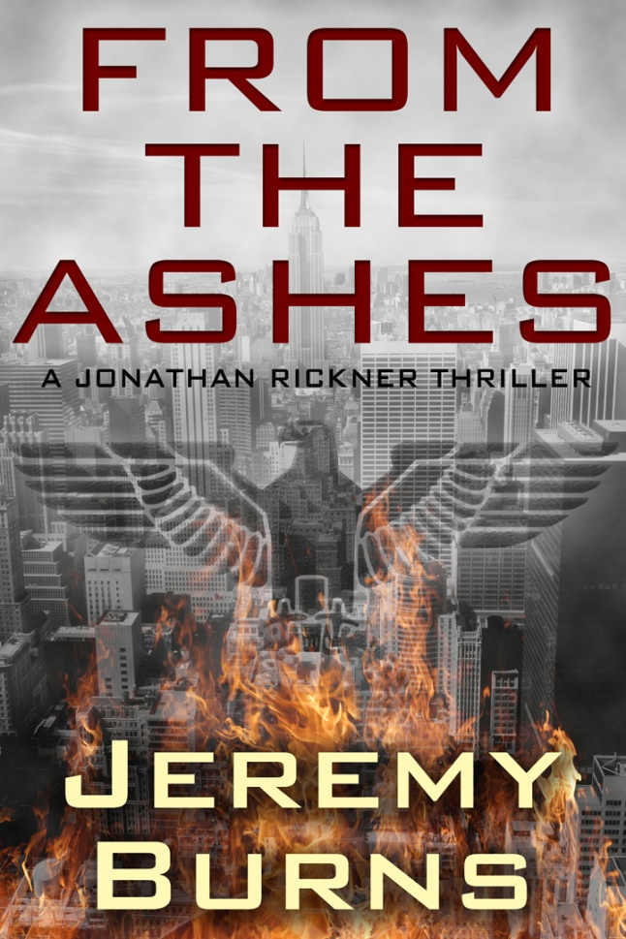
“An ingenious, thought-provoking, and emotionally engaging thriller. This novel will resonate with you for a long time.”
– Lou Aronica, New York Times bestselling author
Kindle and nook versions Available for free April 13-14, 2012
Get yours today and join the adventure!
www.authorjeremyburns.com

